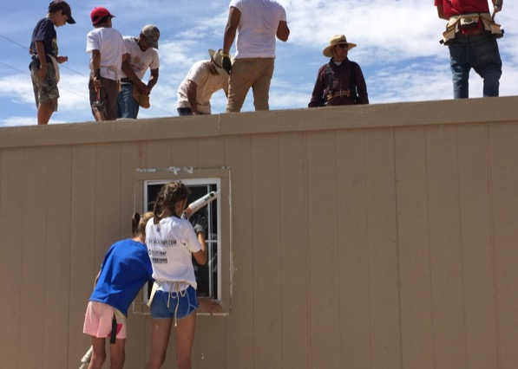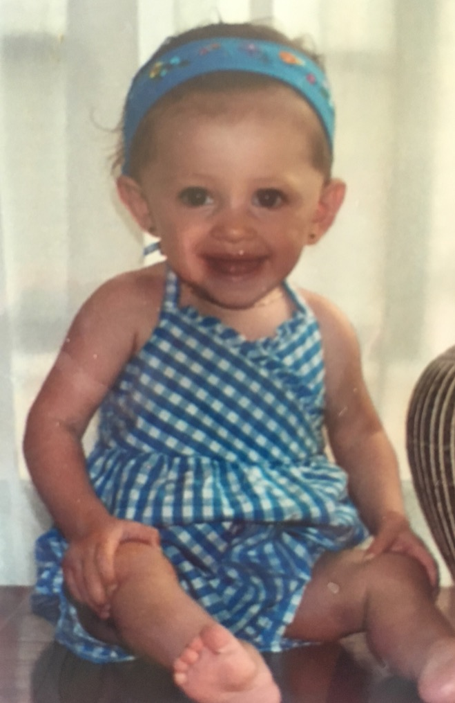

# I AM POEM

BY JADELYN KOPP

I am Jadelyn Kopp

I was clueless I am caring

I was selfish I am thoughtful

I was focused on the I am knowledgable

wrong things I am hard working

I was self - centered I am grateful

I was lazy I am friendly

I was simple minded I am kinda bilingual

I was blind I am understanding

I was shy I am organized

2 weeks ago ago I went to Juarez, Mexico. My family and I went on a mission trip to build houses for families who couldn't afford one. The life style is so different then Castle Rock. There were stray dogs everywhere and children running around with no shoes. It was so hot everyday and the people had no sunscreen or anything to protect them from the sun. There was also garbage everywhere. But yet everyone still had happiness. I couldn't believe all the smiles and excited faces I saw. Their world is hard and to know that even they could have happiness means everyone can find it. That trip really changed my perspective of the world and got to experience real poverty. Also what you have doesn't make you happy it's what you make of it. I was lucky enough to witness that and interact with the people there.

I was I am

I was I am

I was I am

I was I am

I was I am